Mini-DeepClone PoC v1
Final Experiment Summary
Semantic A-CFG + Graph Encoder for Cross-Optimization Binary Function Similarity

1. Objective
The Mini-DeepClone PoC evaluates whether a learned graph representation can identify semantically equivalent binary functions despite compiler-induced changes in instructions and control-flow structure. The final frozen pipeline uses automatic function extraction, basic-block construction, a semantic attributed control-flow graph (A-CFG) with 29-dimensional node features, a GCN encoder, 16-dimensional function embeddings, and cosine similarity.

2. Frozen Pipeline
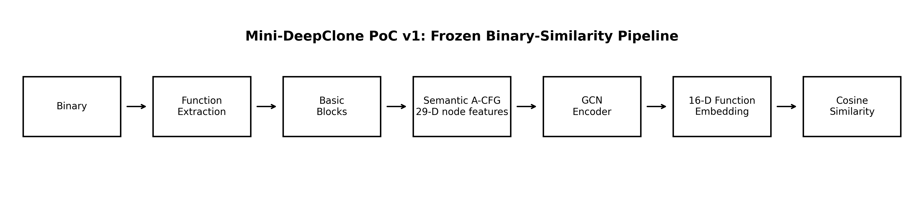
Figure 1. Mini-DeepClone PoC v1 frozen binary-similarity pipeline.

3. Experimental Design
- Compiler variants: Clang -O0, -O1, -O2, and -O3.
- Training/development phase: 10 Phase-1 training families with balanced positive/negative pairs.
- Independent Phase-2 evaluation: 10 previously unseen function families, 40 graph samples, and 120 balanced pairs (60 positive / 60 negative).
- Graph Encoder evaluation: five random seeds (42, 123, 2026, 7, 99).
- Classification threshold: fixed at cosine similarity >= 0.5; no Phase-2 threshold tuning.
- Phase-2 families were not used for model training; the frozen Phase-1 protocol was used for evaluation.

4. Phase-1 Development Checkpoint
Phase 1 is a development/PoC checkpoint and should not be treated as the final generalization result because the representation and training coverage were refined iteratively.
Metric | Mean | Std
Accuracy | 0.9500 | 0.0692
Precision | 0.9401 | 0.0851
Recall | 0.9667 | 0.0745
F1 | 0.9514 | 0.0682
Separation | 0.8068 | 0.1043

5. Phase-2 Independent Evaluation
Phase 2 is the main generalization result. It uses 10 previously unseen function families and 120 balanced pairs. The Graph Encoder was trained only with the frozen Phase-1 training manifest and was evaluated on Phase 2 without further tuning.
Metric | Handcrafted A-CFG | Graph Encoder Mean | Graph Encoder Std
Accuracy | 0.5583 | 0.7517 | 0.0037
Precision | 0.5660 | 0.7071 | 0.0093
Recall | 0.5000 | 0.8600 | 0.0224
F1 | 0.5310 | 0.7759 | 0.0045
Separation | 0.1937 | 0.4755 | 0.0318

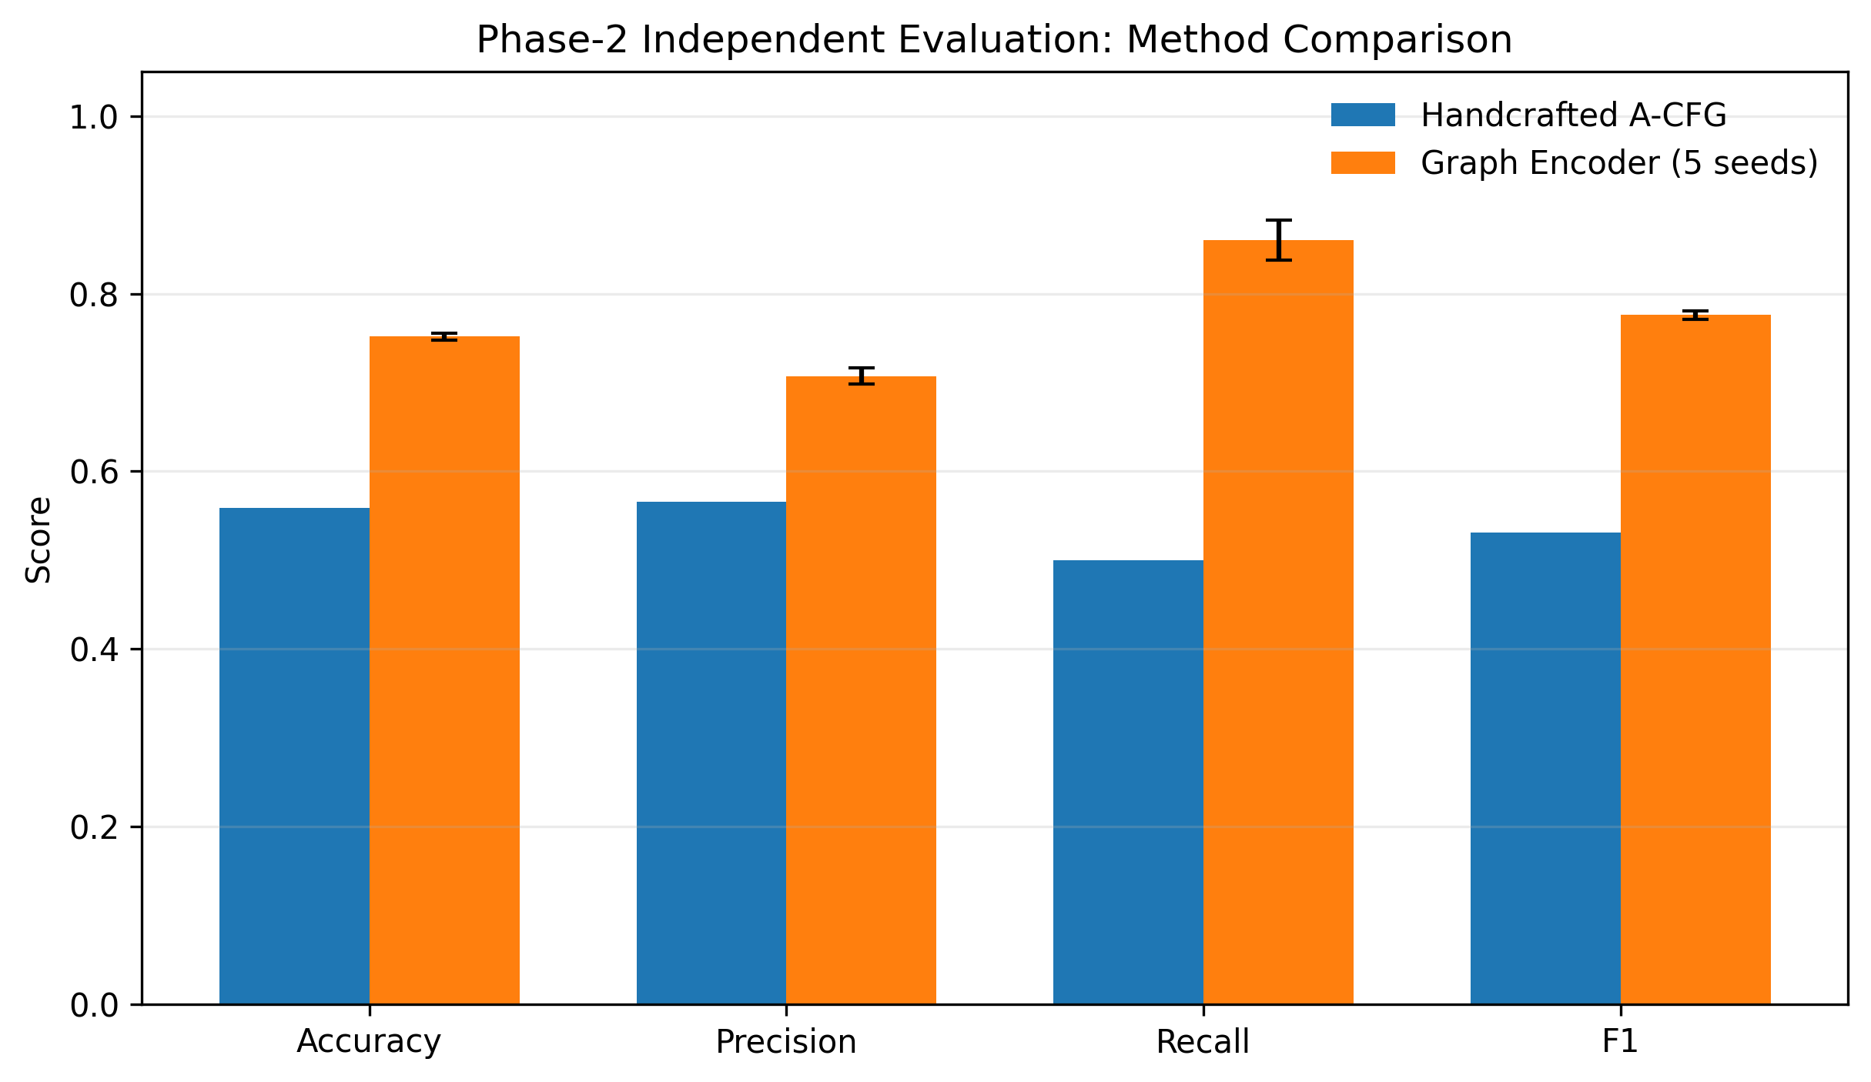
Figure 2. Phase-2 comparison of Handcrafted A-CFG and Graph Encoder.
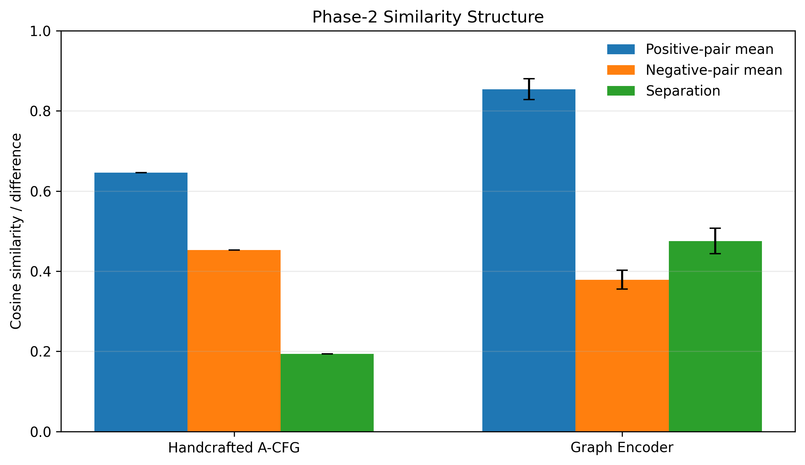
Figure 3. Positive/negative similarity means and embedding separation on Phase 2.

6. Main Findings
- On the independent Phase-2 set, the frozen Graph Encoder achieved F1 = 0.7759 ± 0.0045, compared with 0.5310 for the handcrafted A-CFG baseline.
- Graph Encoder embedding separation was 0.4755 ± 0.0318, compared with 0.1937 for direct handcrafted feature matching.
- The Graph Encoder showed strong cross-seed stability on Phase 2; the F1 standard deviation was only 0.0045.
- Recall (0.8600 ± 0.0224) remained higher than precision (0.7071 ± 0.0093), indicating that the frozen model still tends to generate more false positives than false negatives.
- Phase-1 performance was higher than Phase-2 performance, reinforcing the importance of reporting the independent Phase-2 result as the primary generalization evidence.

7. Interpretation and Limitations
The current evidence supports the conclusion that, on this controlled independent evaluation, the learned graph representation improves cross-optimization binary function similarity detection over direct handcrafted A-CFG feature matching. The result should not be overstated: the project remains a PoC, the independent set contains 10 unseen families, and the evaluation uses a fixed small-scale compiler/architecture setting. Future work should evaluate larger and more diverse function corpora, additional compilers/architectures, and a held-out evaluation set for any revised model.

8. Paper-Ready Result Statement
On an independent evaluation set of 10 previously unseen function families and 120 balanced function pairs, the frozen Mini-DeepClone graph encoder achieved an average F1-score of 0.7759 ± 0.0045 across five random seeds, outperforming a handcrafted A-CFG baseline (F1 = 0.5310). The learned representation also increased positive-vs-negative embedding separation from 0.1937 to 0.4755 ± 0.0318.
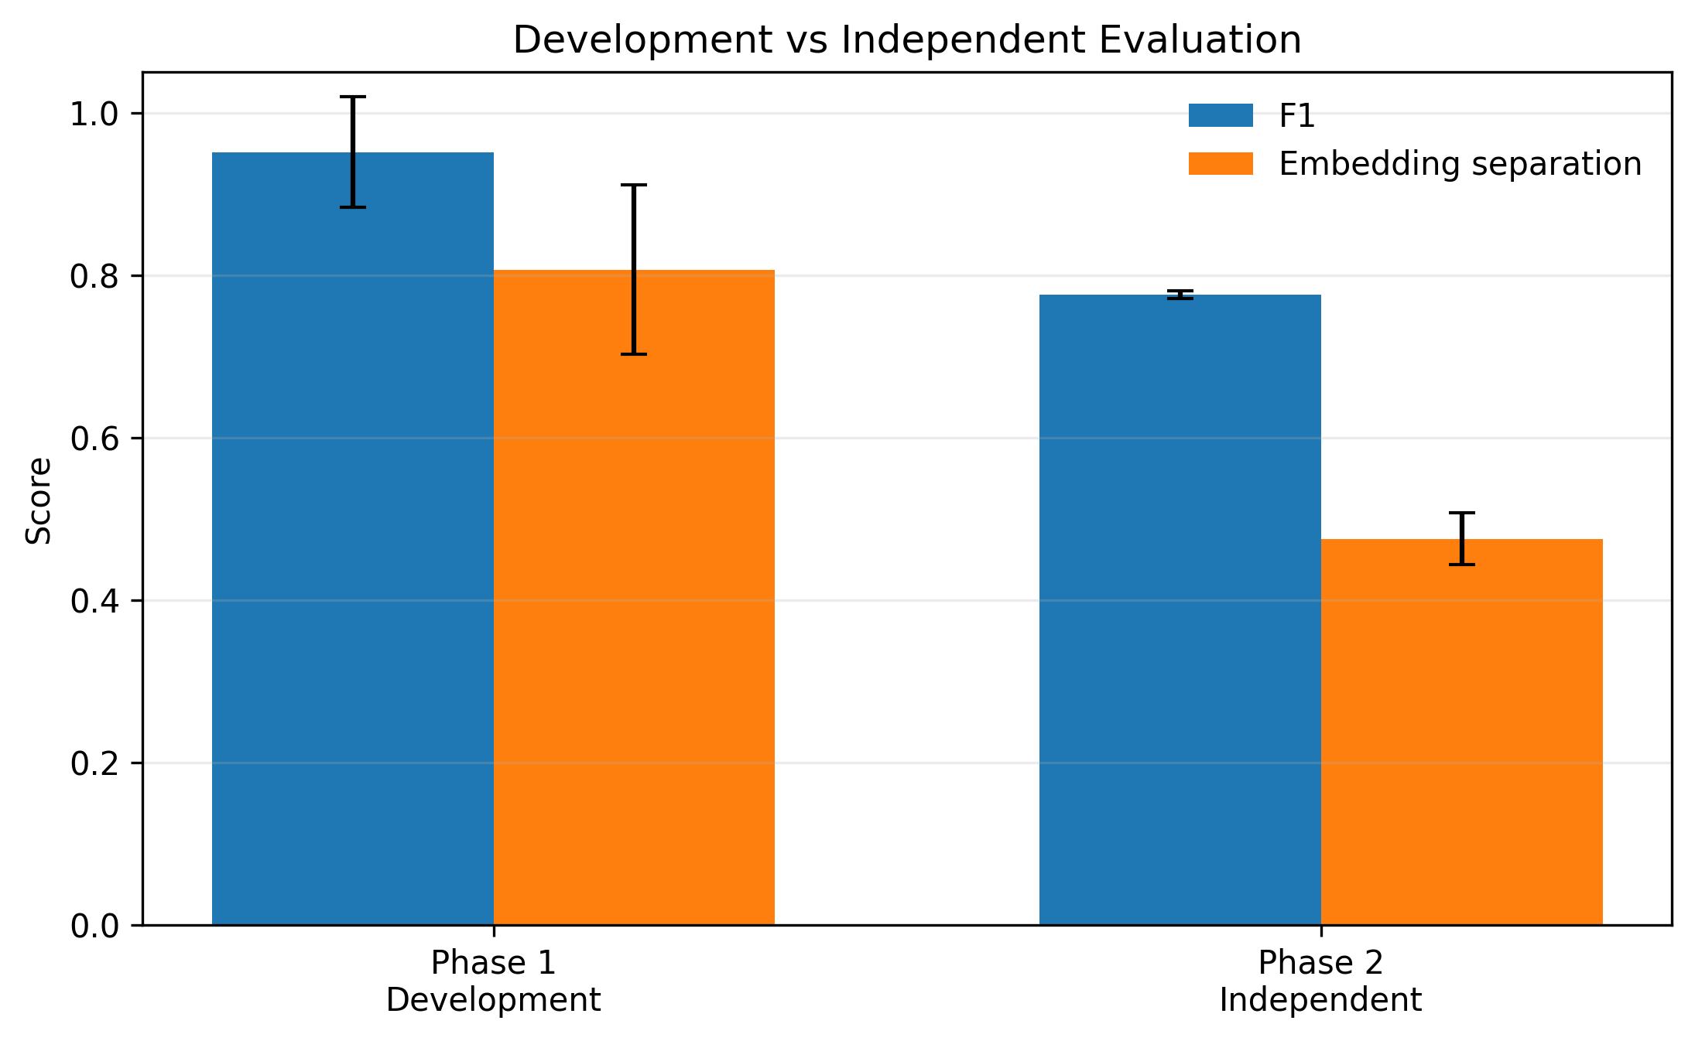
Figure 4. Phase-1 development checkpoint versus Phase-2 independent Graph Encoder evaluation.

